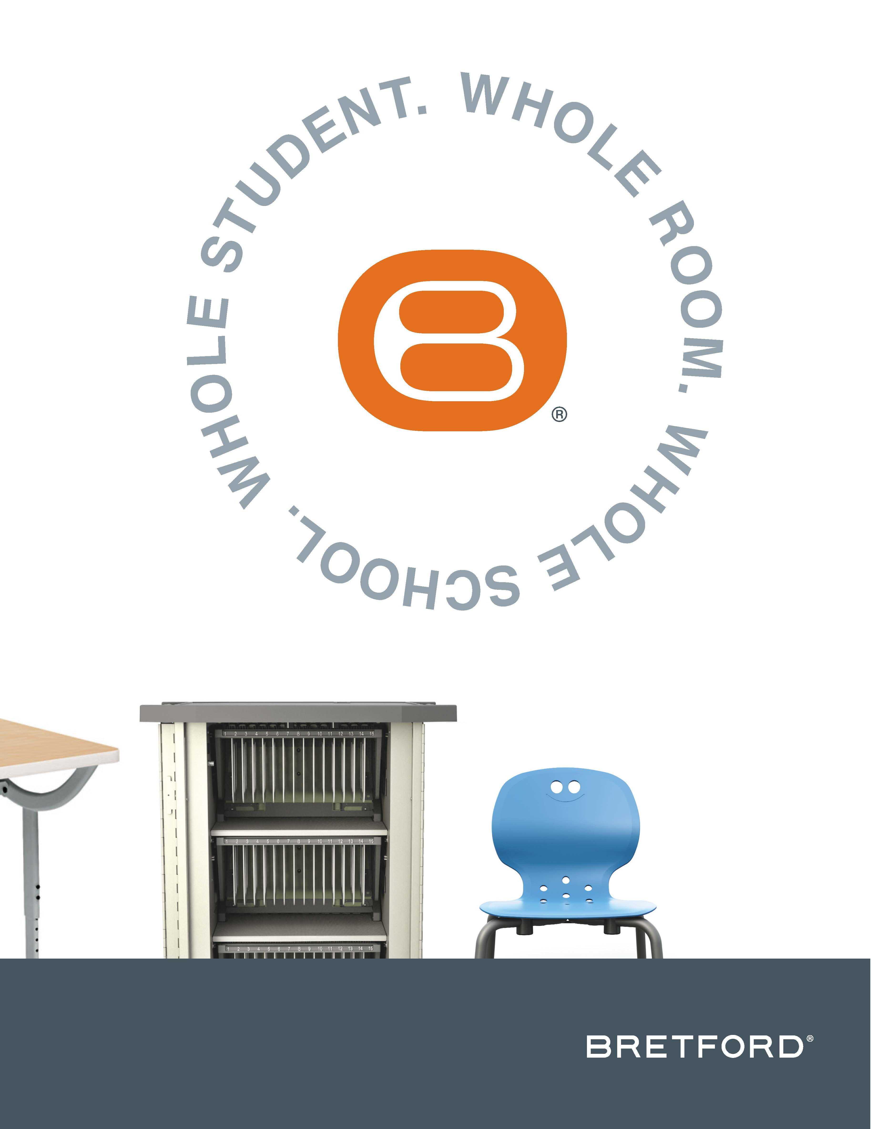

Visit Bretford at NeoCon 2016, June 13-15, Chicago’s Merchandise Mart, Showroom #355

Bretford® Exemplifies “Whole Student, Whole Room,

Whole School” Education Model At NeoCon 2016

Award-Winning Furniture Products, Learning Tools, Research,
and Case Study Examples On Display in Bretford Showroom

CHICAGO, IL — June 13, 2016 — Bretford Manufacturing, Inc.®, a U.S.-based manufacturer of technology-enabled furniture for 21st century learning and working environments, is demonstrating its “Whole Student, Whole Room, Whole School” education model in the Bretford Showroom (#355) during NeoCon 2016, June 13-15 at the Merchandise Mart in Chicago. Show attendees can expect to see award-winning furniture products, learning tools, research, and case study examples focused on preparing today’s students for the future.

“Today’s students will graduate into an interactive, globalized, and contributory world,” explained Cindy Eggebrecht, director of marketing communications for Bretford Manufacturing, Inc. “To prepare them, the whole school learning environment must be more student-centric. At NeoCon 2016, we are sharing the Bretford ecosystem of furniture, which is designed to encourage student-centered experiences powered by interactivity and collaboration. We are also launching the new Bretford Learning Commons, which was created to inspire educational spaces and share best practices for active learning environments.”

According to Eggebrecht, the two newest Bretford furniture families will begin shipping later this year. These products enable Bretford to provide a complete product solution for the K-12 education market space.

Emoji™ Desking + Seating Series
The Emoji Desking + Seating Series meets the sensory needs of children, youth, and adults while keeping the learning space active.

Emoji desks feature a simplified design so they can be rearranged and stacked to fit together and move, which creates an easy planning paradigm. The universal table shape allows classroom planners and instructors to achieve virtually any configuration, cluster pattern, or grid. This helps make classroom transitions less stressful with fewer disruptions for the students. The desks come with either rectangle or convex tops, with a 4-leg or sled base, and with caster, glide, or caster/glide options.

Emoji chairs address the specific physical and emotional needs of every age. Their features boost mood and create a calming effect that builds and maintains a positive experience for children, and a refined, performance-driven experience for adults. The seating is available in bright primary colors and neons to increase energy, creativity, and activity as well as in muted colors to promote relaxation, calmness, and focus. The “textured zones” keep chair parts that are rough away from touch areas, but use them to hold a person firmly in their seat while the rubberized bumpers and quiet casters eliminate ambient noise. All the Emoji chairs have seatback flexibility with a shell design that allows for fluid posture change and spontaneous movement and the perforated seat patterns are slotted for natural aeration.

EVER Cart™ with the MiX Module System™
EVER Cart is designed to be the last store and charge cart a school will need thanks to a future-proof MiX Module System, which involves customizable modules that can be continually modified to accommodate future devices.

The breakthrough MiX Module System is removable, adjustable, and reconfigurable. It is designed to be customized based on electronic needs for both today and tomorrow. With a MiX Module™, shelf heights and device slot sizes can evolve without the need to replace the entire cart. Instead, as new equipment is brought in for use in a classroom, a module within the cart can simply be removed and replaced with an updated module that fits the size, shape, and quantity of the devices being used.

The new EVER Cart can house two shelves with two MiX Modules or three shelves with three MiX Modules to support between 20 and 45 devices. Shelves adjust from 10-inches for tablets and small computers to 12-inches for larger laptops. With the new EVER Cart, it’s possible to create a hybrid cart that supports a variety of different devices using both AC and USB MiX Modules.

About Bretford Manufacturing, Inc.
Bretford is a manufacturer of furniture for both learning and work environments. Founded in 1948 and headquartered in Franklin Park, IL, Bretford holds close to seven decades of expertise dedicated to the design and manufacture of sustainable furniture solutions that are made in the U.S. Each furniture design is built for quality and mobility so rooms, people, and information can move and still stay connected.

The company offers smart furniture designs that support evolving technology, enabling institutions, organizations and corporations to increase productivity and efficiency. Superior workmanship and environmentally-compliant manufacturing and operation practices ensure dependable Bretford products, many of which are GREENGUARD GOLD Indoor Air Quality Certified®. The company is committed to using less energy, creating less waste, and reducing its carbon footprint. Bretford is a CarbonNeutral® certified company and its EDU 2.0 line is among the first in the contract furniture industry to achieve CarbonNeutral product certification.

