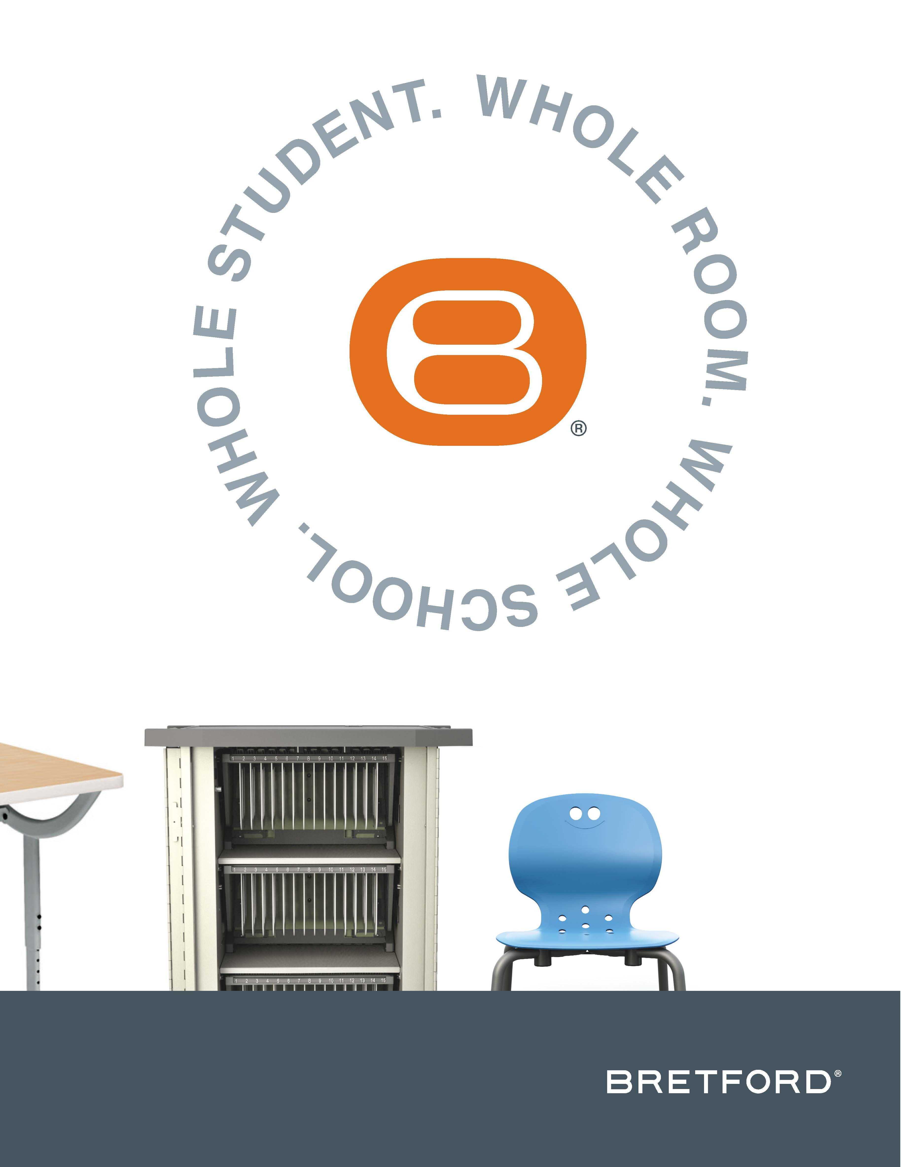

Visit Bretford at NeoCon 2016, June 13-15, Chicago’s Merchandise Mart, Showroom #355

Bretford® Unveils Chicago-Based Digital Atelier

Connected Learning Project and Research Results

Shared Project Gives High School Learners in Low-Performing Chicago Schools a Connected Learning Space; Bretford Furniture Integral to Creating Student-Centered Learning Experiences

CHICAGO, IL — June 13, 2016 — Bretford Manufacturing, Inc.®, a U.S.-based manufacturer of technology-enabled furniture for 21st century learning and working environments, today announced its involvement in a unique Digital Atelier research project by which Chicago-based high school learners are given access to an effective connected learning space. Details about the project and the research results can be found on the newly updated LearningCommons, a page on Bretford.com that houses a variety of information, data, and best practices for active learning environments. The Digital Atelier Research project is being shared in the Bretford Showroom (#355) during NeoCon 2016, June 13-15 at the Merchandise Mart in Chicago.

The Digital Atelier (DA) is an in-school, student-centered makerspace that provides a safe, creative environment for students to learn and explore digital media under the guidance of artists and other professionals. The program’s goals are to engage students more deeply in their learning, increase their achievement in core content areas, improve their college and career readiness, and develop communication, problem solving, and creativity skills. To view a video about the Digital Atelier, click here.

Bretford partnered with Convergence Academies at Colombia College Chicago and Archeworks to provide furniture for Digital Ateliers in two high need, traditionally low-performing Chicago Public Schools: Tilden Career Community Academy High School and Donald L. Morrill Math & Science Elementary School. Over the last two-and-a-half years, Convergence conducted ethnographic observations with a University of Illinois at Chicago School of Education research team, collecting evidence of the DA’s impact on student learning, youth identity development, school culture, and teacher innovative practice.

“It was an incredible experience to be able to provide our powered furniture for the Digital Ateliers and see how the students connected and took pride in the work they created in the learning space,” said Cindy Eggebrecht, director of marketing communications for Bretford Manufacturing, Inc. “The furniture in both Digital Ateliers is modular in nature and is designed to be moved easily to create flexible configurations for the teachers and the students. We are confident that the results from the research will inevitably drive more schools to adopt this inspirational learning model. It is currently the only study where the outcomes actually show an improvement in grades and attendance.”

“We express our profound gratitude to Bretford for the commitment to bringing technology and new ideas to schools and learning environments,” said Don LaBonte, co-director for Convergence Academies, Center. “It was Bretford’s deep level of involvement that enabled Convergence Academies to fully realize its lofty vision for the Digital Atelier as a model for a 21st century incubator of learning and creativity, as well as improving the field of K-12 education through research and sharing of models that work.”

Mindy Farber, co-director for Convergence Academies added, “We were thrilled to collaborate with Bretford on this research summary. As a company, Bretford completely grasped the forward-thinking concepts, learning sciences, and theories driving the creation of the Digital Atelier.” She added, “Bretford’s focus on human-centered design and technology-rich, agile spaces aligned perfectly with the connected learning model that Convergence was implementing.”

Farber noted that most parents and educators acknowledge how important it is for students to be engaged in school and yet there is precious little research that actually examines the critical role that space, furniture, and designed environments can play. “The key findings from this research will be of tremendous value to architects, educators, and designers who want to better understand how to build vibrant ecosystems that authentically center on the needs of the learner. Undoubtedly, curriculum and instruction are vital but it is the space and the layout of resources in that space that make learning truly come alive and accessible to all students.”

“It is almost impossible to quantitatively measure the impact the DA has had on students who utilize it,” said Sharon Holmes, English teacher at Tilden High School. “Qualitatively, I see students who are more engaged, more confident in their abilities, and more willing to take risks in the classroom. I see students who are learning to be leaders in the school. I believe the DA is saving lives, both figuratively and literally.”

Some of the key research findings include:
- “Connected learning” in which students are free to explore topics that interest them in an informal setting, is important to students’ academic and personal growth – and schools can play a vital roles in fostering this type of learning.
- The design of learning spaces is critical to students’ success. When students have access to flexible, comfortable learning spaces and are given a choice in their learning tools, they are inspired to create and explore.
- Mentors trained in a connected mentorship model play a significant role in building the capacity of students and teachers to use digital media in support of learning.
- The Digital Atelier motivates reluctant learners to attend school, resulting in improved attendance and GPA.
- Participation in the Digital Atelier increases students’ communications skills through a variety of technologies and media.
- Students who frequently visit the DA receive over 100 hours of additional information learning time while they are at school each year.

About the Bretford LearningCommons
The Bretford LearningCommons is a website for sharing and learning about the successes of active learning environments. It brings a collection of key concepts, research, thought leaders, strategies, and tactics together in one place to support schools moving toward active learning environments. To view the LearningCommons, go to www.Bretford.com/lc.

About Bretford Manufacturing, Inc.
Bretford is a manufacturer of furniture for both learning and work environments. Founded in 1948 and headquartered in Franklin Park, IL, Bretford holds close to seven decades of expertise dedicated to the design and manufacture of sustainable furniture solutions that are made in the U.S. Each furniture design is built for quality and mobility so rooms, people, and information can move and still stay connected.

The company offers smart furniture designs that support evolving technology, enabling institutions, organizations, and corporations to increase productivity and efficiency. Superior workmanship and environmentally-compliant manufacturing and operation practices ensure dependable Bretford products, many of which are GREENGUARD GOLD Indoor Air Quality Certified®. The company is committed to using less energy, creating less waste, and reducing its carbon footprint. Bretford is a CarbonNeutral® certified company and its EDU 2.0 line is among the first in the contract furniture industry to achieve CarbonNeutral product certification.

