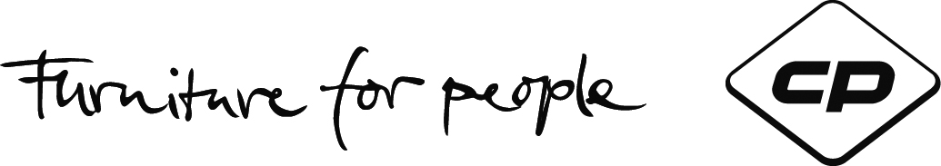
Press Information
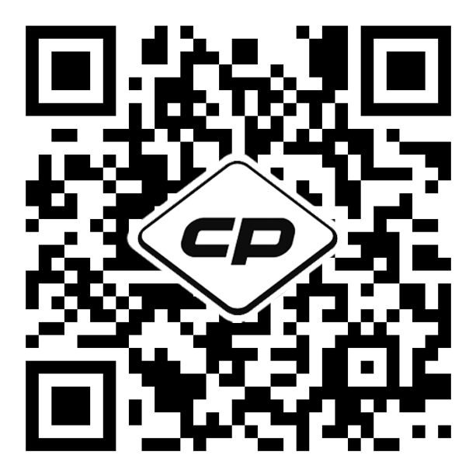
Office work is only enjoyable
when water flows from the wall...
CP is the first furniture manufacturer in the world to offer
a climate control, humidification, and greening system.

When they see a wet wall, people normally fear burst water pipes right away. Not so at CP: The German furniture experts, who have established their reputation through intelligent technology integration in high-quality furniture, are initiating the next stage of success: mobile and permanently installed special walls for climate control, humidification, and interior greening – a world-wide first in this combination.

It all started with the CP climate wall. Based on a Fraunhofer patent and developed by CP, this system makes it possible to cool rooms in a completely new way that is clean, energy efficient, and healthy. It eliminates or compensates all of the disadvantages of conventional air conditioning systems. The cooling water film also "disposes of" minor air pollutants, such as dust and pollen (a relief for allergy sufferers!), and enables systematic humidification and dehumidification inside buildings.

Mobile water walls and green walls for the office

This concept has been decisively expanded. For now it includes not only the climate walls but also other elements. Water walls do not require a water connection or drain for operation in the mobile version. Just like the climate walls (which have a cooling and dehumidifying effect in summer), the water wall is truly eye-catching and enhances the room by virtue of its design and the way it operates. The climate and water walls are extremely beneficial even if cooling is not required, for the pleasant humidification helps to maintain employee health. Another addition includes green walls, on which real and easy-care plants grow. The planting also has a positive impact on the indoor climate and is even acoustically effective. All three elements (climate, water and green wall) represent a system solution which can be integrated in a partition and implemented as a free-standing or even mobile version. The climate, water, and green wall will be on display at NeoCon 2016.

No more boring meetings!

"Meetings have to be smart and enjoyable!", according to another CP credo. The company was the first European manufacturer to take the topic of media technology seriously, and integrated the first wireless charging modules in its products six years ago. At the NeoCon, the company will display furniture that meets various requirements for smart and efficient meetings. The flagship of its presentation is the Cegano SmartTable. It only needs a power connection; everything else works without cables in all current standards. A suitable output medium for the table is the SonicWall Smart, a mobile stand-up wall with an integrated monitor, which also interacts wirelessly with the table and allows different devices to share content. Since the SonicWall Smart Curved convinced the Jury in 2015, CP took home a GOOD DESIGN award. Each year, The Chicago Athenaeum presents the GOOD DESIGN Awards Program for the most innovative and cutting-edge designs produced around the world.

In addition, CP will be presenting some elegant and exceptional materials. For example, several tabletops will be made of Corian®, a high-quality and attractive solid surface material. It can be used to create seamless, organic shapes and translucent effects – as in the Workflow sit/stand workstation and in the smart, interactive counter solution for visitors. There will be many more exciting furnishing solutions to see at the CP showroom. It seems that the German manufacturer will again rank among the most memorable exhibitors of the NeoCon.

(approx. 3,675 characters – reprint/reproduction free of charge)

NeoCon / The Merchandise Mart, Chicago / June 13-15, 2016 / Suite 10-166

CP Furniture Systems belongs to the Christmann & Pfeifer Group that was founded in 1925 and has a yearly turnover of around 180 million euros.
This German manufacturer operates throughout the world, employing over 1000 people at home and abroad. Its unique selling points include market leadership in elegant steel furnishings as well as intelligent, user-friendly integration of technology in modern furnishings for practically all areas of use, e.g. offices, conference and meeting rooms, changing facilities, bistros, workshops, warehouses, laboratories and many more. The range of services starts with the supply of individual items and ends with full-service contract furnishing. www.cp-furniture.com

Press contact:
CP Furniture Systems Inc., The Merchandise Mart, Suite 10-166, Chicago, IL 60654
Oliver Kapp (National Sales Manager, North America)
Phone +1-805-905-9231, US toll-free: 800-242-3450, oliver.kapp@cp-furniture.com

