

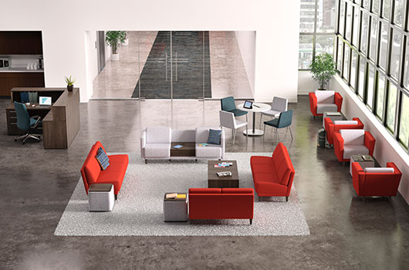

**Grove™ - Where Comfort and Connectivity Come Naturally**

**Fact Sheet**

**Top Features**

* Available Q3 2016
* A customizable lounge seating line designed to welcome and connect users in a variety of settings without sacrificing comfort
* Plush seats and backs allow users to get comfortable quickly, while multiple arm options and leg finishes create a differentiated look
* It’s easy to stay connected with optional integrated table surfaces that include power outlets and tablet accessories

**Where It Works**

* Grove lounge seating welcomes guests in reception areas and encourages productivity and interaction in break rooms, meeting spaces and private offices

**Product Details**

* Grove lounge seating comes in a variety of sizes:
  + 1-Seat: Use as a standalone solution, in small space settings or as part of a larger configuration
  + 2-Seat: Use as a single loveseat or as part of a larger configuration
  + 2-Seat with Table: A table between two seats provides separation and creates a usable worksurface for guests that can be powered to keep technology fully charged
  + 3-Seat: The full 3-seat sofa is capable of supporting a small collaborative meeting or bringing guests together in a cozy, comfortable space
* Tapered square and tapered round leg options, available in 7 solid hardwood finishes or two polymer finishes, allow you to match any desired aesthetic
* Available with no arms, straight arms or tapered arms
* The 2-seat with table option adds personal space within a public space
* Make a bold statement when you select from hundreds of high-quality HON fabrics or dress it up with dual fabric options for limitless design possibilities
* Designed through collaboration with Brian Kane
* Backed by HON’s Full Lifetime Warranty