

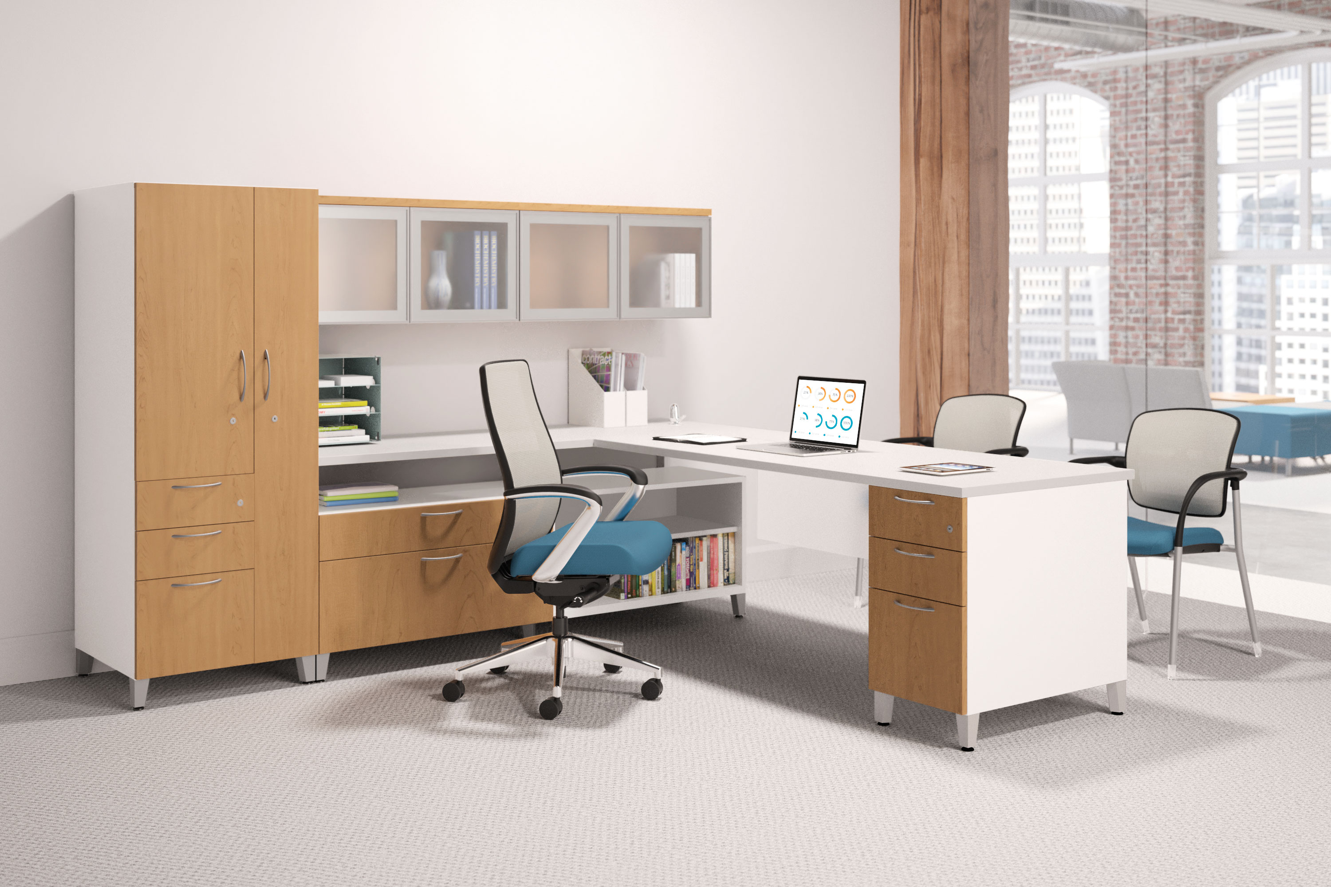

**Contain® Storage – Organization from the Inside Out**

**Fact Sheet**

**Top Features**

* Contain credenzas, pedestals and towers are an everyday steel storage solution that redefines active and anticipated storage, delivering a cohesive design that ties an entire office together
* Designed with durable steel frame that ensures it will perform at a high level for years to come
* The entire family of Contain credenzas, pedestals and towers offer an upscale aesthetic to complement any space and offer easy access to everyday items
* Contain provides active and anticipated personal storage that delivers value with its coordinated, tailored platform and user-friendly design, while adapting to the condensing work environment

**Where It Works**

* Whether used independently or integrated with HON workstations and desk solutions, including Accelerate™, Abound®, and Voi®, the uniform design and flexible layout configurations allow greater freedom for workplace planning
* Contain turns any workspace into a hub for collaboration by using seat cushions with low credenzas and pedestals that invite and accommodate short-term seating
* The variety of sizes, shapes and types of storage keep everything within arm’s reach, and make it perfectly suited for today’s shrinking workspaces

**Product Details**

* Durable steel frame and mixed material options
* A combination of open shelves and drawers as well as options for finishes, bases and tops
* Choice of metal or durable, stain-resistant woodgrain laminate fronts
* Base options of platinum metallic feet or recessed or flush kickplates
* Top options turn the credenza or pedestal into short-term seating by adding seat cushions or a laminate top to coordinate with existing HON desks and workstations
* Pulls include Arch, Integral and Radius options which match HON product lines
* Credenzas and towers accommodate right- and left-handed configurations
* Backed by HON’s Full Lifetime Warranty

For more information about Contain, visit hon.com/contain.