Press Release

June 13-15, 2016
NeoCon ITOKI Booth #7-7034
Chicago, Illinois

As one of the leading office furniture companies in Japan, ITOKI focuses on the concept of innovation of office products, work style, and workplace to create the most practical, comfortable, and refined space for our customers since our founding in 1890. We believe that there is endless potential in everything we do and consistently pursue the establishment of creative and inspiring spatial environments. We aim to create office solutions that take into consideration knowledge exchange, globalization, health of workers, and environmental issues. The competitive power of our products and services stems from our extensive network both throughout Japan and internationally.

Japan is renowned for its quality. ITOKI Group is as well, and we want to share this with the world. NeoCon is one of the channels for us to present ourselves to the world. We have spent decades perfecting our craft and building our know-how so that we can meet the needs of customers across the globe. Our R&D and production capabilities and diverse procurement and sales networks enable us to fashion office and commercial spaces that transcend business domains and borders. We are currently expanding business in Asia and North America by developing international brands and leveraging our relationship with local partners.

This year, ITOKI will introduce the following new products to the customers.

Contact Details
YOSHI KONISHI / Creative Director
ITOKI Corporation New York Branch

147 W 35th street, 15th floor
New York, NY 10001
Phone: 212-217-0642
Email: info@itokiusa.com
New Product Information

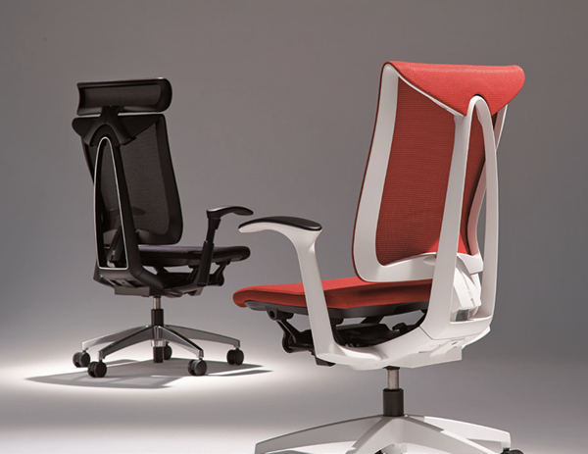
CE Chair
The depth and the rocking of the CE Chair is adjusted automatically with the surface of the seat to fit the body. The functions are made to adjust easily and automatically to make it user-friendly. It conforms to the user however they are sitting. The structure of the Type A frame is soft, expressing elegance. The Japanese idea of hospitality is built into this design.

The PSS (Passive Slide Seat) mechanism allows the rear of the seat to sink with the user. This motion actuates the ALS (Active Lumbar Support) and the lumbar support automatically moves forward.
Using the PSS and ALS mechanisms, the CE chair supports your lower back and keeps the spine in an ideal S-shape even when changing postures or stooping forward in the chair.

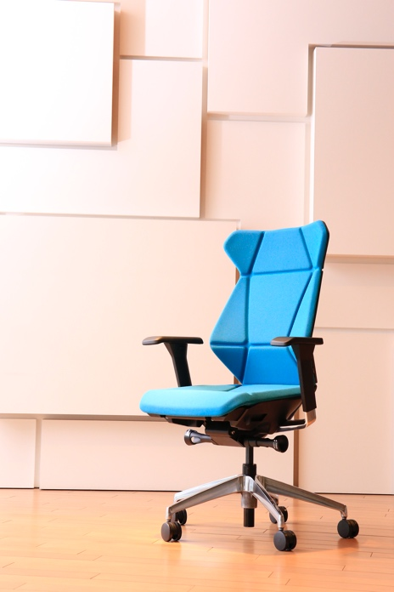
FF Chair
The FF Chair features a multifaceted design inspired by origami, the Japanese art of folding paper into three-dimensional figures. The shape of the backrest changes automatically to support the body and react to the changes in posture, making it comfortable whether working or relaxing. It offers the comfort that is suitable for various office workers regardless of their build and posture.

TO Table
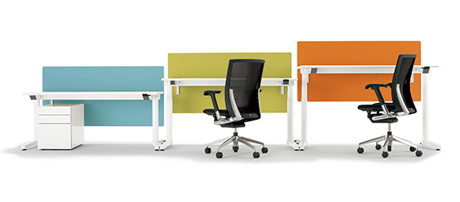The TO Table is a height adjustable table with a unique aluminum base shape. The height of the table is adjustable to fit the needs of everyone, regardless of size and build. The table can be adjusted from 25-50 inches to fit a sitting position and a standing position. There is a safety function for the table height movement to stop if an obstructing object is detected.

Es Cabinet
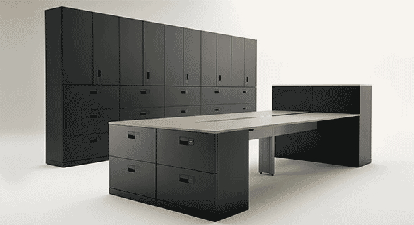
The Es Cabinet is equipped with the new ITOKI digital lock system. The cabinets can be locked with an ID card, or the new sliding touch panel which feels like a smartphone. It automatically locks when closed. The cabinet is completely flat and is earthquake proofed, leading office storage to a new stage.

NB Chair
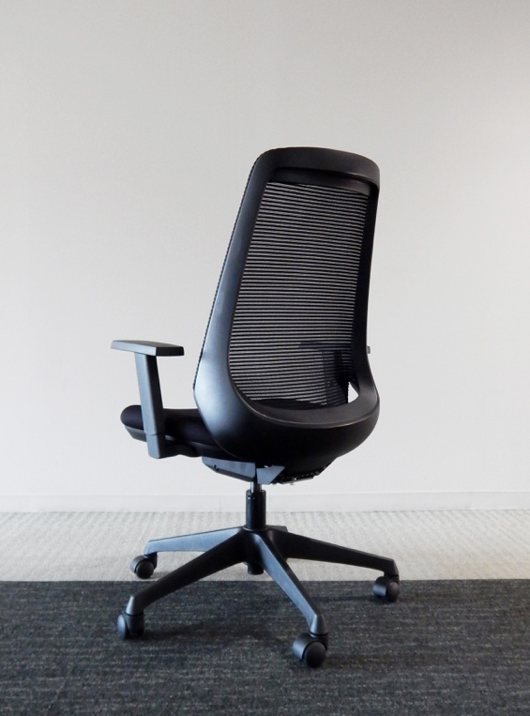

The NB chair is an elegant chair with a unique backrest frame and a self-adjust rocking mechanism.
The key to comfort is the curve of the backrest. By applying the Fit and Free concept, its tapered shape keeps your shoulders free, allowing your arms to reach out to any direction, as the top part of the backrest is narrow and the bottom is wide.

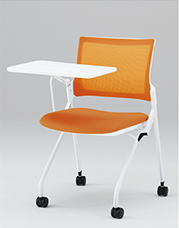
MN Chair
The MN Chair features a compact design, but still offers great comfort. The seat is made for less fatigue over time, and it contains a spacious surface. It has many variations for meeting, training, and educational situations.
The width of the chair is 24”, so three chairs can fit in a 70” wide table. If the seat is flipped up, multiple chairs can be nested for horizontal stacking. This allows for easy storage.

