Press release
NeoCon 2016

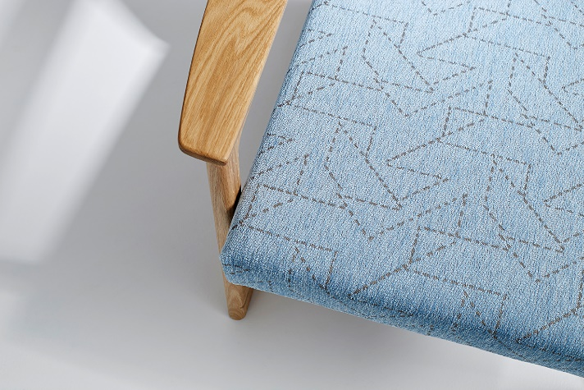
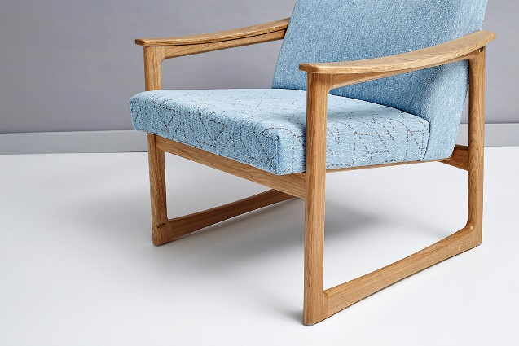
Introducing Track and Trail – Camira’s new luxurious Trevira CS Chenille fabrics, launching at NeoCon 2016.

Track and Trail are the newest Trevira CS chenilles from global textile innovator, Camira, demonstrating the latest in performance fabrics.

Suitable for fixed or removable upholstery in a range of interior applications, Track and Trail have a soft and relaxed appearance with beautiful aesthetics, yet are still high performing.

As an environmentally friendly alternative in the fight against spills and stains, Track and Trail are designed to handle the toughest scenarios without needing to resort to backcoatings and chemical treatments. Both fabrics are inherently and permanently flame retardant, thick enough to capture spills and the removable covers can be washed to 140 degrees Fahrenheit. Used as fixed covers, the fabrics are very durable and ideal for areas where spills and stains are less likely.

Inspired by hand crafted design, Track has a textural slub with two-tone color interest. Trail features a subtle geometric stitch line emulating a ‘one-off’ handmade feel and echoes its trend origins of exploration, adding richness and interest to the weave.

Track is available in 18 colorways of classic mono shades and playful contrast colors, and Trail is available in 10 color options to coordinate with the plains in Track.

Harriet Green, Camira’s Product Manager, commented: “Track & Trail make intelligent use of design and technical engineering; created not only to be aesthetically pleasing but also stand up to the toughest interior scenarios.”

For more information about Camira’s products visit www.camirafabrics.com/us.

Camira at Neocon: Showroom 11-23A
- Ends -

For further information, please contact: Jennifer Isles, Communications Manager
T: +44(0) 1924 481144 M: +44(0) 7957 142094 E: jen.isles@camirafabrics.com
Notes to editors:
- Camira designs and manufactures upholstery fabrics for commercial offices, hospitality, government, institutional interiors, healthcare, cinema and auditoria.
- Camira is an independent UK textile company with two manufacturing facilities in England (in Huddersfield and Nottingham) and a mainland European manufacturing plant in Lithuania. The company’s North America operation is in Grand Rapids, MI, where it holds stocked inventory and operates a cut yardage program for rapid distribution throughout North America.
- The company was founded in 1974 as Camborne Fabrics, acquired by U.S. modular flooring company Interface Inc. in 1997, and Camira was born out of a management buy-out in April 2006, taking the company back into independent ownership.
- Camira employs about 650 staff and sells some 10 million yards of fabric annually, generating revenues of approximately $100 million.
- The company has been recognized for outstanding product innovation and environmental stewardship, gaining Queen’s Awards for Sustainable Development (2015 and 2010) and Enterprise in Innovation (2005).
- Camira is registered to ISO 9001 (quality standard), ISO 14001 (environmental management) and OSHAS 18001 (health & safety) and OSHAS 18001 (health & safety).

