Press release
NeoCon 2016

Prints, patterns and palettes of textile colors – Camira’s latest fabric collections at NeoCon

Global textile innovator, Camira, is pushing color palettes and patterns to the max at this year’s NeoCon with the Synergy Collection, comprising three new wool blend fabrics: Synergy, Individuo and Zig Zag.

Synergy
Synergy is the newest addition to the manufacturer’s extensive wool blend fabric collection, which is a high-performance seating fabric and includes its largest color offering of 75 intelligent shades.
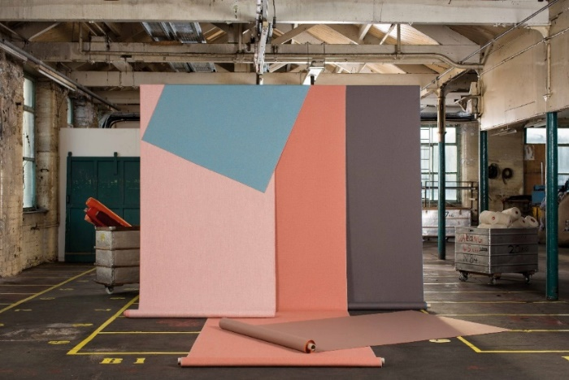
Synergy by Camira

Synergy is a natural evolution of Camira’s bestselling wool fabric, Blazer. It’s softer and stronger, lighter and brighter. Made from premium New Zealand wool and combined with just 5 per cent nylon, Synergy has a finer finish while achieving 100,000 double rubs.

The Synergy palette boasts an enchanting kaleidoscope of colors suitable for a wide range of interior environments. The development of each colorway was a thoughtful and considered process, from fiber-dyed to piece-dyed fabrics, the colors range from bold brights, neutral pales, deep darks and mysterious mélanges.

Hayley Barrett, designer of the Synergy range, observed that “creating Synergy has been a journey of discovery. We wanted to give architects and designers the full spectrum of colors that complement one another. Experimenting and using colors together, or selecting tones that work well with other materials, opens up new combinations and surprising color stories.

“Synergy is a progression from Blazer and although it maintains similarities, the wider color range and inclusion of nylon means we’ve been able to develop a fabric that looks beautiful but also stands up to the toughest scenarios.”

As water is a core utility for wool textile manufacturing, Camira is supporting international water aid charity, Just a Drop, with its Wool for Water campaign to help deliver accessible, clean and safe water where it is needed most. For every yard of Synergy sold, Camira will make a donation to a project in Kenya.

Individuo
Being unique is all about being different and this is just the case with Individuo, Camira’s tie-dye effect fabric on Synergy.
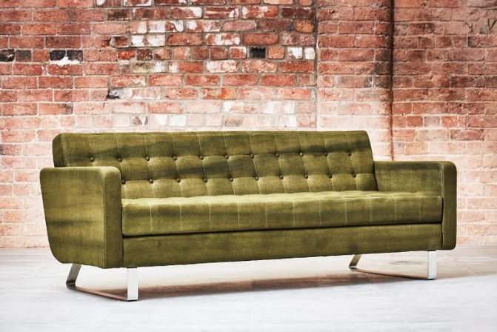
Individuo by Camira

Individuo has a distinctive look and feel, and is available in four contemplative colorways. Its fluid, graduated color appearance is ever-changing and ensures no two areas of fabric are the same. It is inspired by the Artisan trend which romanticises handmade, handcrafted, creative artwork and textiles.

Zig Zag

Zig Zag is a playful print by UK designers Parris Wakefield Additions who specialise in bold, colorful, graphic patterns.
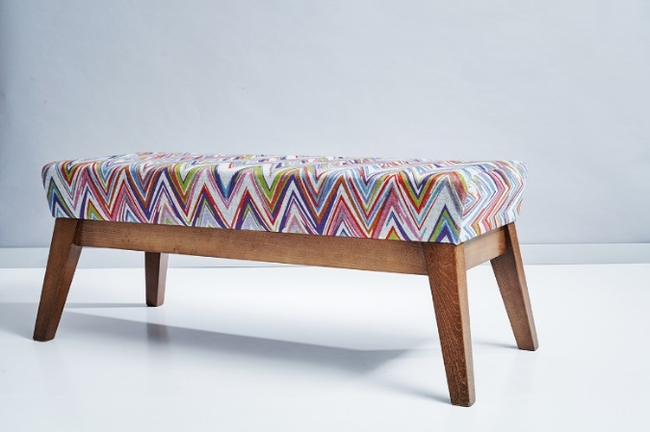
Zig Zag by Camira

The pattern is made up of parallel lines of varying angles, widths and colors, creating a fun and visually appealing upholstery fabric. Zig Zag is printed onto Camira’s Synergy fabric and has been designed to coordinate with Synergy.

The Synergy Collection

The Synergy Collection combines beautifully relaxed drape with sublime handle and shows the versatility of this wool-rich fabric. With a range of color combinations from the extensive range of 75 shades in Synergy, working alongside a bold and bright print with Zig Zag or stand out from the crowd with the unexpected and intriguing tie-dye pattern of Individuo.

Combining new colors, designs and techniques, working together and separately, all in Synergy.

For more information about Camira’s products visit www.camirafabrics.com/us.

Camira at Neocon: Showroom 11-23A

- Ends -

For further information, please contact: Jennifer Isles, Communications Manager
T: +44(0) 1924 481144 M: +44(0) 7957 142094 E: jen.isles@camirafabrics.com
Notes to editors:
- Camira designs and manufactures upholstery fabrics for commercial offices, hospitality, government, institutional interiors, healthcare, cinema and auditoria.
- Camira is an independent UK textile company with two manufacturing facilities in England (in Huddersfield and Nottingham) and a mainland European manufacturing plant in Lithuania. The company’s North America operation is in Grand Rapids, MI, where it holds stocked inventory and operates a cut yardage program for rapid distribution throughout North America.
- The company was founded in 1974 as Camborne Fabrics, acquired by U.S. modular flooring company Interface Inc. in 1997, and Camira was born out of a management buy-out in April 2006, taking the company back into independent ownership.
- Camira employs about 650 staff and sells some 10 million yards of fabric annually, generating revenues of approximately $100 million.
- The company has been recognized for outstanding product innovation and environmental stewardship, gaining Queen’s Awards for Sustainable Development (2015 and 2010) and Enterprise in Innovation (2005).
- Camira is registered to ISO 9001 (quality standard), ISO 14001 (environmental management) and OSHAS 18001 (health & safety) and OSHAS 18001 (health & safety).

