FINDING (LOS)T ANGELES
Bentley Tells the Story of Urban Reinvention through the Lens of Latest Carpet Tile Collection

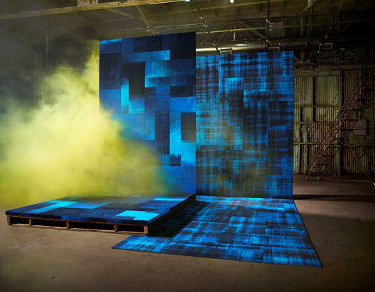

LOS ANGELES (April 2016) – Every city is a story of juxtaposition – of conquest and sin; loss and growth; decay and renewal. Los Angeles is no different, a sprawling, open book that somehow manages to be gritty and razor-sharp while living up to its laid-back, sun-drenched bohemian reputation. Through the lens of its latest carpet collection, Bentley contrives the next chapter of its narrative with (los)t angeles.

Beneath the surface of its beloved City of Angels, Bentley – California’s largest commercial carpeting manufacturer – reveals a surprising world of hidden and forgotten places in the midst of unexpected transformation at NeoCon 2016.

Los Angeles is revered by many, but for the uninitiated or unobservant, John Lennon described it best: “Los Angeles? That’s just a big parking lot where you buy a hamburger for the trip to San Francisco.” Imagine what he might have found had he traveled beyond the fringe to catch a glimpse a city that thrives in the shadows. This misunderstanding – a collision of new and old, strange yet brilliant, lost then found – is Bentley’s muse.

“Los Angeles has an aptitude for reinvention so strong that its deep roots are easily overlooked as new buildings grow over the old,” explained Todd van der Kruik, vice president of design for Bentley. “The gems of LA are hidden in plain sight. Our (los)t angeles Collection goes beneath the glitz and glamour and behind the urban decay to discover extraordinary, exciting and unexpected things.”

BENEATH THE SURFACE
Comprised of two styles, the (los)t angeles collection examines rich, textural patterns with a range of seven colorways that span from urban-inspired neutrals to vibrant, saturated hues. Underground™ brings forth large-scale abstract blocks of substantial color while Trespass™ comprises an exaggerated scale of pixelated plaid.

Featuring the latest in pattern tufting technology, both (los)t angeles styles are made with Antron® Lumena™ Type 6,6 Solution-Dyed Nylon for ultimate color and performance. (los)t angeles products are available in NexStep® Cushion Tile and AFIRMA™ Hardback Tile in 24in x 24in and 18in x 36in.

The products are Cradle to Cradle Certified™, NSF® 140 certified and CRI Green Label Plus certified, and produced in a LEED®-EBOM Gold-certified manufacturing facility.

###

About Bentley
Defining style, color, quality and service for more than 30 years, Bentley Mills, Inc. manufactures and markets award-winning broadloom, carpet tile and area rug products for all commercial interiors across the globe. Bentley is recognized for leadership in product design, style and customer service. Bentley is committed to sustainable commerce, and, as the largest commercial carpet manufacturer in California, the company operates in a LEED®-EBOM Gold carpet mill. For more information, contact Bentley at 800.423.4709 or visit us at bentleymills.com or on Facebook, Twitter, Pinterest, LinkedIn, Instagram and Google+.

Media Contact
Rachel Auerbach
rauerbach@sternstrategy.com
908-325-3898

