KARNDEAN DESIGNFLOORING ADDS 22 NEW ON-TREND DESIGNS TO POPULAR DA VINCI COLLECTION THIS SPRING

A market leader in luxury vinyl flooring, Karndean Designflooring is eagerly anticipating the May 2016 introduction of 12 new wood and 10 new stone designs as part of its long standing Da Vinci range.

The new Da Vinci collection is a fresh take on today’s trends of natural look colors and reclaimed designs. Taking inspiration from the narrow planks that were standard in early 20th Century homes, the wood looks enhance the collection with new, on-trend ‘modern rustic’ designs. The 10 stone looks offer weathered industrial, textile, and natural visuals that represent the very essence of Karndean’s innovative ability to recreate products from the natural world in LVT.

The inspiration for the wood and stone designs can be characterized by natural, reclaimed and weathered, and fabric looks.

Naturally classic
The three classic Oak designs, Natural Oak, Harvest Oak, and Blended Oak, provide a traditional and clean-lined style in shades ranging from light to mid-brown. The stones in this group were inspired by natural limestone. Ranging from the pale, sandy tones of Dune to the darker, grainer Sable and Drift, these tiles incorporate subtle design and neutral complexions for an incredibly authentic look.
Reclaimed and weathered
With an alluring color variation from plank to plank, our two new Acacia designs and Scorched Oak have been designed to replicate the look of burnt timbers. The other two designs in this group, Coastal and Beach Driftwood, mimic the sea salt worn features of reclaimed driftwood. These distinctive rustic designs offer the natural look of reclaimed timber without the practical drawbacks of real wood such as cracking, splintering, or warping.
The four stones in this group were inspired by weathered steel for a unique, industrial appearance. Molten represents the striking rust characteristics of the original oxidized product, while Iron Ore and Eisen feature this effect with muted tones. Carbon is the most subtle of the four and the dark color accentuates the original weathering.

Fabric-textile
Inspired by natural fibers and textiles, the soft muted tones of the four Limed Oak designs, Limed Silk, Limed Jute, Limed Linen, and Limed Cotton, are enhanced with an eye-catching limewashed finish, accentuating the unique grain details of each plank.

Serving as a distinct change of pace from the collection’s traditional stone designs, Burnet, Cambric, and Sindon take their inspiration from natural woven fabric and lightly brushed concrete. These design carriers are a perfect fit for a contemporary space.
For those looking to make a creative statement with their floor, the stone and wood designs in each of these groups can be paired together for a blended arrangement. The design possibilities are endless.

Available with a Lifetime residential warranty and 20 year commercial warranty , the complete Karndean Da Vinci collection will feature 16 wood and 14 stone designs.

For more information visit www.karndean.com

For press enquiries, please contact Ben Moriarty, PR & Media Manager at Karndean Designflooring, email: ben.moriarty@karndean.com, tel: 888-266-4343, x2002.

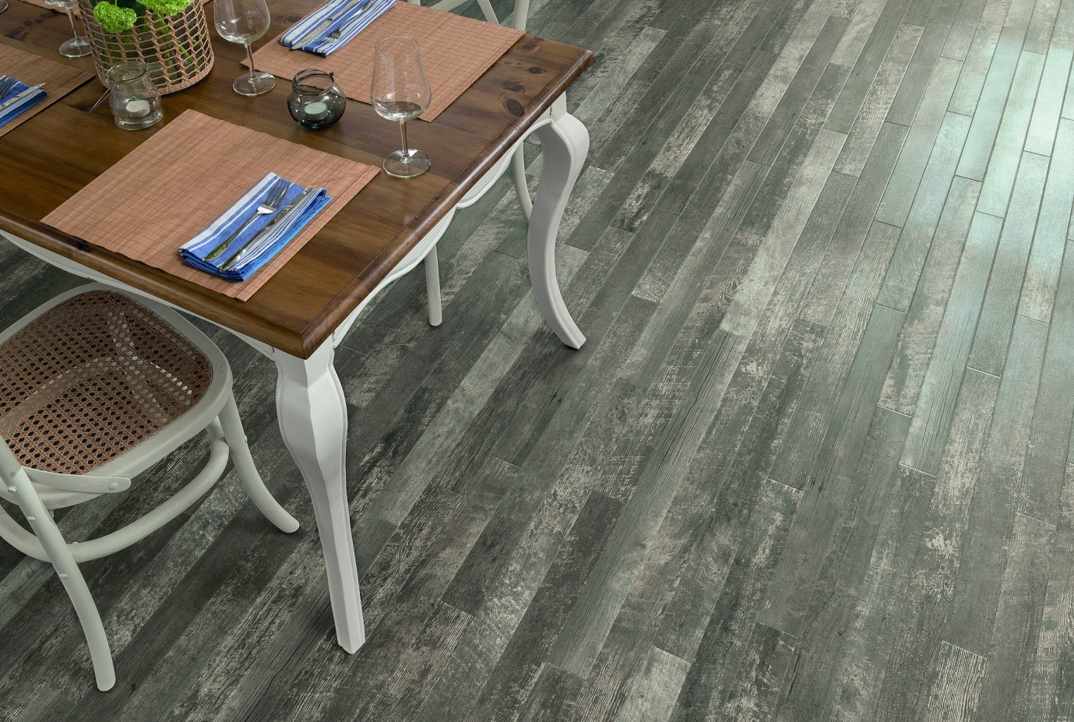RP100 Coastal Driftwood

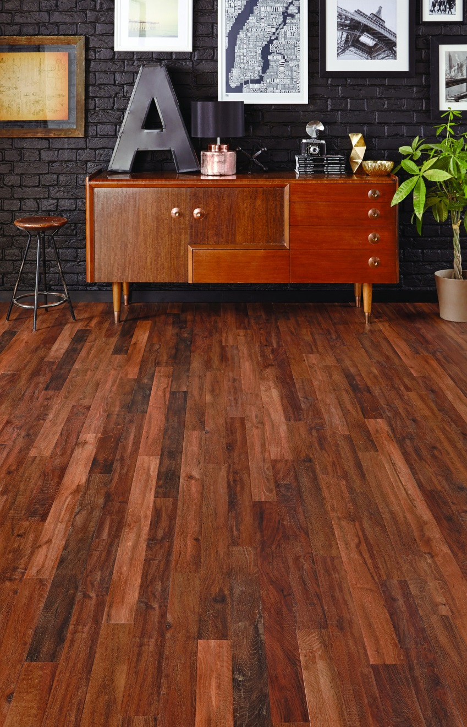
RP104 Single Smoked Acacia

About Karndean Designflooring:
Karndean Designflooring is a global leader in flooring design with operations in the USA, UK, Australia and New Zealand. By offering a wide range of colors, textures and finishes, our products allow you to create looks that are unique to your home or business and are guaranteed to last. With a passion for creating floors which are both stylish and practical, we're here to help customers find the right floor for their space, needs and unique style.
For more information about the company, and to view its full range of flooring products, please visit: www.karndean.com, or follow us on our Facebook (http://www.facebook.com/KarndeanDesignflooring), Twitter Residential (http://www.twitter.com/KarndeanFloors) or Twitter Commercial (http://www.twitter.com/KarndeanComm).

###

