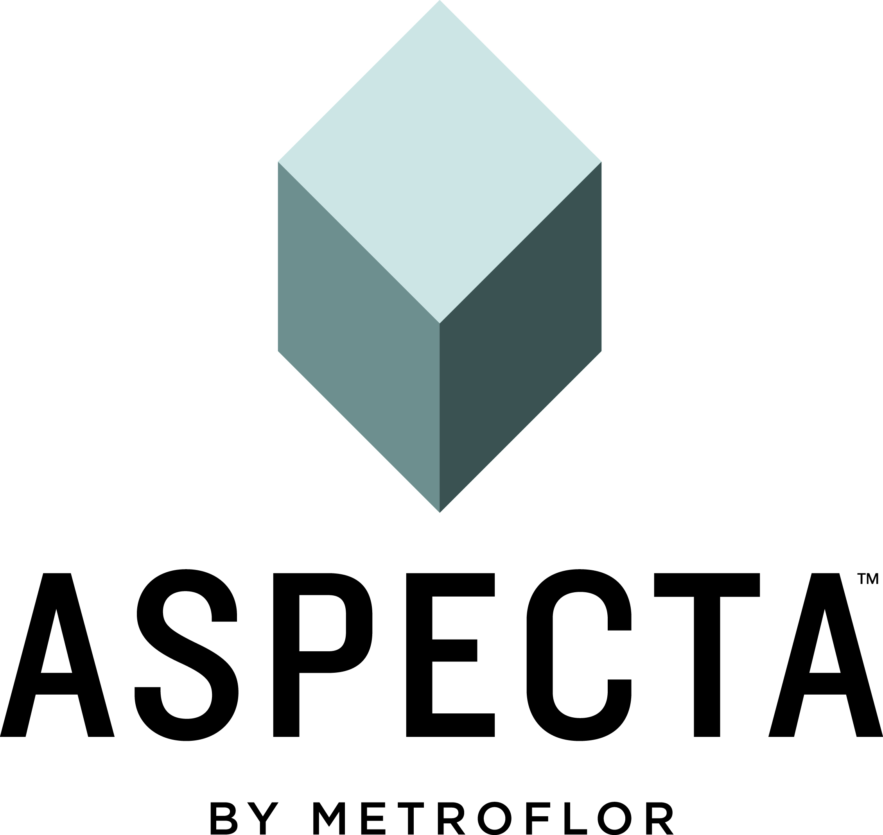

ASPECTA LAUNCHES NEW PREMIUM FLOORING RANGE
NORWALK, CT -- ASPECTA by Metroflor has announced the launch of ASPECTA TEN, its second LVT flooring range developed for the contract market. The collection combines advanced technologies in a floating floor system that matches the look of natural wood and stone finishes, while delivering the durability and comfort that only LVT provides.
With 24 planks and 10 tiles, the designs span dramatic dark wood tones, rich urban concrete, and unique time-enhanced leather: stunning flooring options for a wide spectrum of contract specifications, designed specifically for retail, hospitality, assisted living and corporate spaces.
Design innovations include larger plank and tile formats that feature the latest in-register-embossing techniques for a more authentic look.
The range has been developed with a pioneering new technology called ISOCORE.™ ISOCORE is an extruded, closed-cell PVC structural core that delivers rigidity and strength to ASPECTA TEN while making larger formats easier to install through advanced, state of the art, locking technologies. This unique Structural LVT composite results in a floating floor that is waterproof and also provides superior sound insulating characteristics through its pre-attached, polyethylene acoustical underlayment. Therefore, there is no need for a separate sound mitigator.
Here is a selection of ASPECTA TEN products:
Brindle Oak is a time-worn, weathered wood. Its soft grain and subtle colors give any room a feeling of instant comfort and familiarity, creating a warm, welcoming mood that can unify a space without over powering it.
With a deceptively rich concrete detail, Urban Grid can enhance many design approaches, offering a versatile, contemporary dimension. The scale of this concrete patterning and the color range provide a very expansive offer.
Fulton Hyde delivers a strikingly unique LEATHER patina, in two rich tones. Intricate rivulets of wear cracks tell the story of age worn proudly, a well-loved item whose comfortable folds and blemishes are only enhanced by time.
Unique attributes to this category of product include:
- 100% Waterproof
- Floor Score Certified
- Strong, rigid and dimensionally stable
- Installs over most existing hard surface floors including ceramic tile
- Helps minimize telegraphing from subfloor imperfections
- Unquestionably offers the most underfoot comfort of all LVT-type floors

- Ultra Fresh Treatment on the surface, core, and integrated within the attached underlayment helps retard the growth of bacteria, yielding a healthy floor
Metroflor President and CEO Russ Rogg commented: “We’re predicting that this latest collection will delight existing fans of LVT and also convert more new customers to the category. For example, those who would typically consider real wood, stone or even laminate flooring will be won over by the excellent design, color and textures that not only offer quieter flooring but enhanced warmth and comfort under foot too. These products not only look fantastic but when combined with a 28 Mil commercial wear layer, offer durable protection from abrasions, scuffs, chips and indentations that plague real wood and stone surfaces. ASPECTA TEN really is a whole new dimension in flooring.”

For further information visit www.aspectaflooring.com
Follow us on Twitter @Aspectaflooring

# # #

US PRESS CONTACT AT NEOCON BOOTH 8116:
Susan Bang PR
sbang@susanbang.com
917-991-9714

