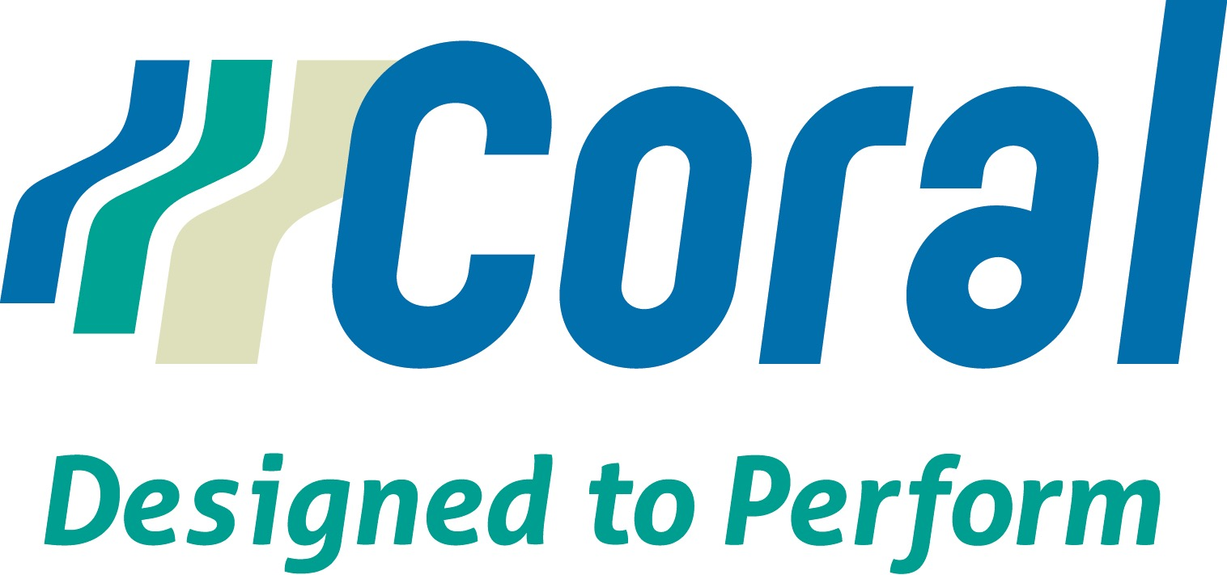

FOR IMMEDIATE RELEASE

Coral Fabrics Celebrates 40th Anniversary, New York, NY, 2015

Coral Fabrics, a major purveyor of Contract textiles, is celebrating 40 years as the go-to fabric resource for Healthcare, Institutional, Government, Educational and Corporate environments. Founded in Chicago, Coral was originally known as “Coral of Chicago” and initially made its name as a purveyor of casements - open weave drapery, widely used in office windows at the time. In its first ten years, Coral rose to become one of the leading suppliers of casements for corporate office spaces. As the market began to change, demand grew for different types of fabrics at the window and elsewhere in contract spaces. Coral expanded its product line to include upholstery fabrics, cubicle curtains and other types of textiles for drapery, meeting the demands of the evolving market.

In 2001, Coral was purchased by Charles Samelson Inc., whose far reaching resources supported Coral in further expanding its product offerings. Today Coral provides privacy curtains, barrier fabrics, vinyls, woven upholstery, sheers, and narrow and wide width prints for window, seating, top-of-bed, accessories and shower curtains — all inherently fire resistant (IFR) and designed to perform in contract environments.

Coral has developed a strong custom textiles department and is a leading source of custom fabric created to meet the design and performance specifications of properties in its key markets. Working with the client property and/or interior designer, Coral will create the desired design in the colors specified, printed on an IFR base cloth or woven, as required.

Coral’s Customer Service Team and state-of-the-art warehouse facility in South Carolina deliver impeccable service. Coral stocks thousands of yards of its wide variety of fabrics and will ship small or large quantities when and where you need them. Add to that competitive pricing and you’ll understand why Coral has a reputation for being a one-stop textiles resource for
Healthcare, Institutional, Government, Educational and Corporate spaces.

Visit Coral’s website to explore the multitude of choices in it’s vast product library using the dynamic search engine. Order a memo on-line or call 1.800.621.5250.

Contact: Graham Marketing Group
805.448.9418; marcy@gramargrp.com

102 Madison Avenue, 6th Floor 1.800.621.5250
New York, NY 10016 coralfabrics.com

