From the makers of Boinks® –
a toy for all ages from 3 to 103
Recommended by parents and therapists

Slide the marble back and forth to sooth fidgety fingers

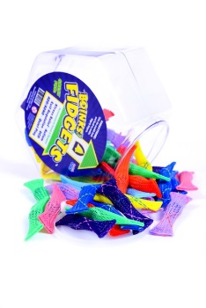
People of all ages will enjoy and reap the benefits from Fidgets. This toy is perfect for anyone -

- Kids on the go
- Young adults in school
- Athletes preparing for the big game
- Individuals with ADD or AD/HD
- People with obsessive compulsive disorder, dementia, or autism
- Sufferers of Parkinson’s and / or Arthritis

The many purposes for Fidgets –
- To calm nerves and reduce stress – from general anxiety to test taking to public speaking….
- Stimulates neural responses increasing blood flow
- Improve range of hand motion and restore motion of joints
- Strengthen finger muscles, hand muscles and joints
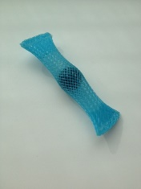
- To help curb nail biting, smoking, and gum chewing
- Fun to collect and share with friends

Fidgets can be used anywhere –
- Classrooms to Board rooms
- Theaters, offices, conferences
- Airplanes, bus rides, car trips
- Waiting rooms, dentist and doctor offices

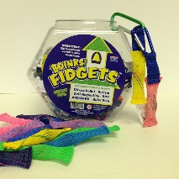
Fidgets are colorful, discrete, and dishwasher safe. Fit perfectly in the palm of your hand and in your pocket for later use. Fidgets are also available with a carabiner for attaching to belt loops, backpacks, brief cases, or purses. Fidgets with carabiner is a great key chain!

